Birla Institute of Technology & Science, Pilani
Work-Integrated Learning Programmes Division
Second Semester 2019-2020
M.Tech (Data Science and Engineering)
Mid-Semester Test (EC-2 Regular)

Course No. : DSECL ZG555
Course Title : DATA VISUALIZATION & INTERPRETATION
Nature of Exam : Open Book
Weightage : 30%
Date of Exam : 08/11/2020
No: of Questions : 8
Note: These instructions must appear above all questions.
- Start the answer in a new page.
- Cleary mention the assumptions made, if any

Answer All the Questions
(Start every question in a new page)

1. | Describe how a scatterplot can be used to show the relationship between sales and profit across different product types and market. | 2M
2. | Explain with an example how time can be treated as continuous and discrete. Plot profit over Months [2011, Jan-2014, Dec, all months’ data is present] to point out the difference in visuals because of the difference in treatment. | 2M

3. | All three charts below are plotting the same data-Sales over years .Which one do you prefer? Why? Also mention the reasons for rejecting others.  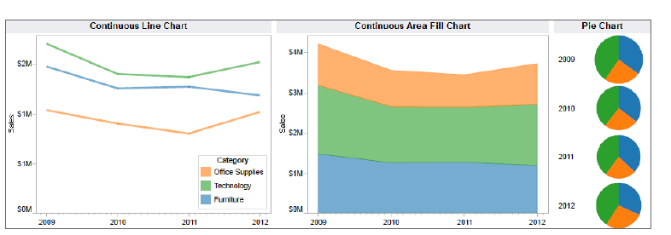 | 2 M
4. | How do you ensure the goodness of fit of a regression model [which is a measure of the quality of the model's predictions] in Tableau? Demonstrate with a visual. | 4M
5. | In a final exam for DVI course at BITS Pilani, there was a design question. The data values below are the grades achieved for the answer to that question, broken down by whether the student used a systematic method, or not. No grades were given for using a systematic method, grades were awarded only for answering the question.  A systematic method is any method that assists the student with problem solving. For example, a strategy could be to identify the visualization context, identify the visual, eliminate clutter, focus audience’s attention, think like a designer and implement the viz.  Draw two box plots next to each other, true to scale [scale: 1unit=5grades] that compare the grades of students who did, or did not use a problem solving strategy.  Comment on the features you notice in the comparison. | 5M
  MethodUsed | MethodNotUsed
  11 | 11
  8 | 8
  20 | 17.5
  18 | 4.5
  14 | 2.5
  21.5 | 26.5
  8 | 15
  18.5 | 22.5
  28 | 26
  10 | 24
  27 | 4.5
  16.5 | 26
  25 | 5.5
   | 4
   | 12
   | 16
   | 9.5
   | 25
   | 11
   | 2.5
   | 28
   | 2
   | 28
   | 15
   | 7.5
   | 15
   | 9
   | 12.5
   | 17
   | 21
   | 14
   | 16
   | 7
   | 18.5
   | 19
   | 2
   | 19.5
   | 3
   | 6
   | 28
   | 28
   | 19
   | 11
   | 16
6. | The below visual uses 2 quantitative variables-Total sales and % of Total sales. The height of each segment is giving the % of each company’s total sales handled by each sales channels-US, International and Licensed. The width is giving the value of each company’s sales. Sales of each company through each channel is encoded by the area of the segment.  Redesign the Visual, without information loss, with appropriate choice of display medium/s to make it more effective. Present only the final version of the graph/s and list down the proposed changes and the reasons.  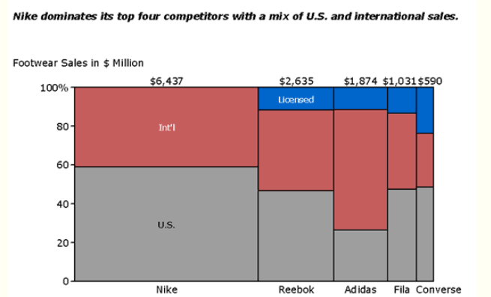  Image credit: mekkographics.com | 5M
7. | In the below visual, use gestalt principles of visual perception to identify at least 4 groups. Clearly mention which principle is used to group the marks.   | 2M

8. | The below visual shows conversion rate over time by acquisition channel. Assume you’d like to draw your audience’s attention to the REFERRAL line. How could you use preattentive attributes to do so? Come up with different visuals to focus your audience’s attention[1 mark each].  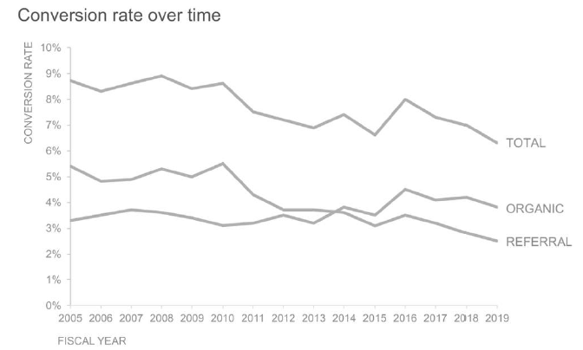 | 8M

